HOW IT WORKS AND HOW TO OPPERATE IT

Receivable Aging Report for the Company NGMC - a wholly owned subsidiary company of the Nigerian National Petroleum Corporation (NNPC) incorporated on July 16, 2016 to market and distribute Natural Gas nationally and to regional African markets, I used excel to create an aging report, using DATEDIF to display the number days between the due date and the period ending, and then use AND and IF to compare number days to the date range and place the outstanding to the appropriate date range. This setup reduces workload and creation of new sheets.
All the user needs to do is change the period date to which time period you want and the outstanding number of days will change
The formula used is: =DATEDIF(I6,$J$4,"D")

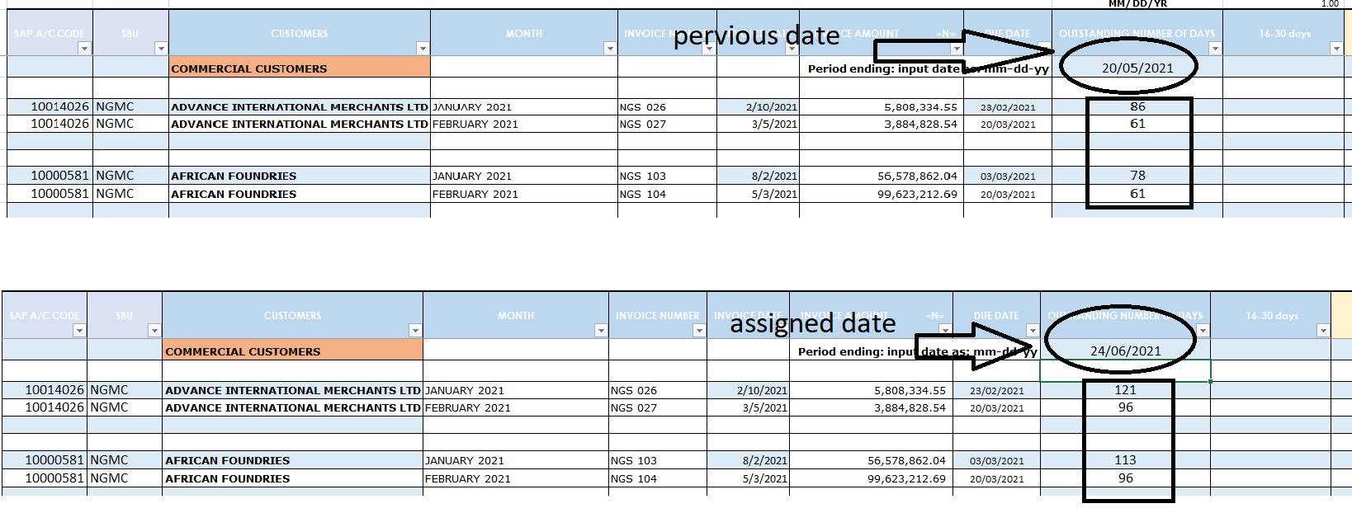

The outstanding number days is now compared to the range days numbers 30, 60, 90 etc. and place the outstanding amount in the appropriate column
The Formula used is: =IF(AND(J6>=91,J6<=180),H6,"")
This formula was assign on each date range column and rows
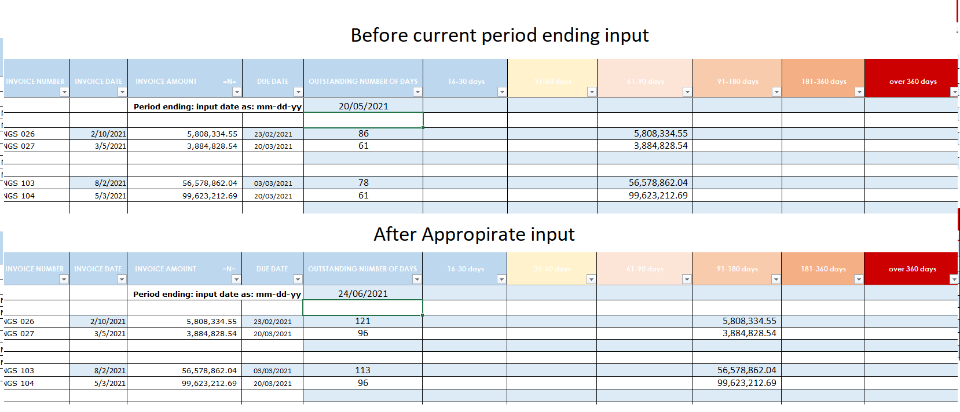
All this is right after you input the company name, date of invoice, due date and outstanding amount in the table, which is derived from another report sheet called the weekly(also in the repository) this sheets gives us weekly information of invoice to the companies NGMC supply to and how much the company were able to pay every month. The age analysis is to understand how long ago each outstanding payment is.

